Homework 2, I guess

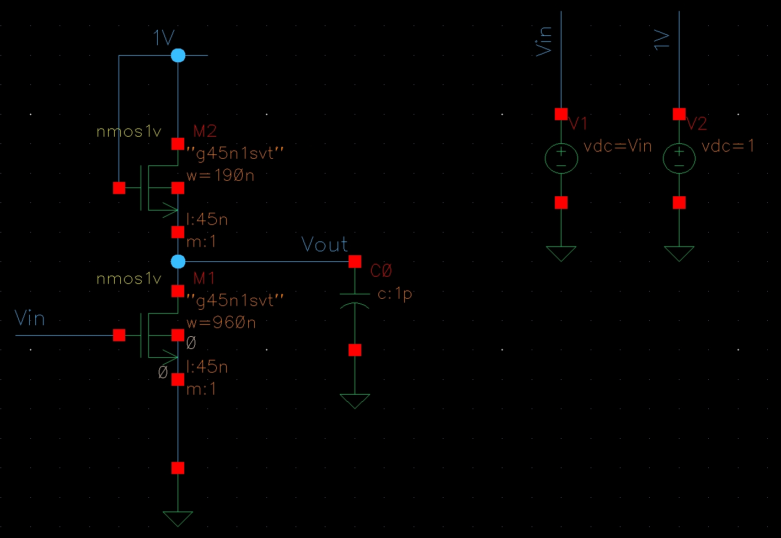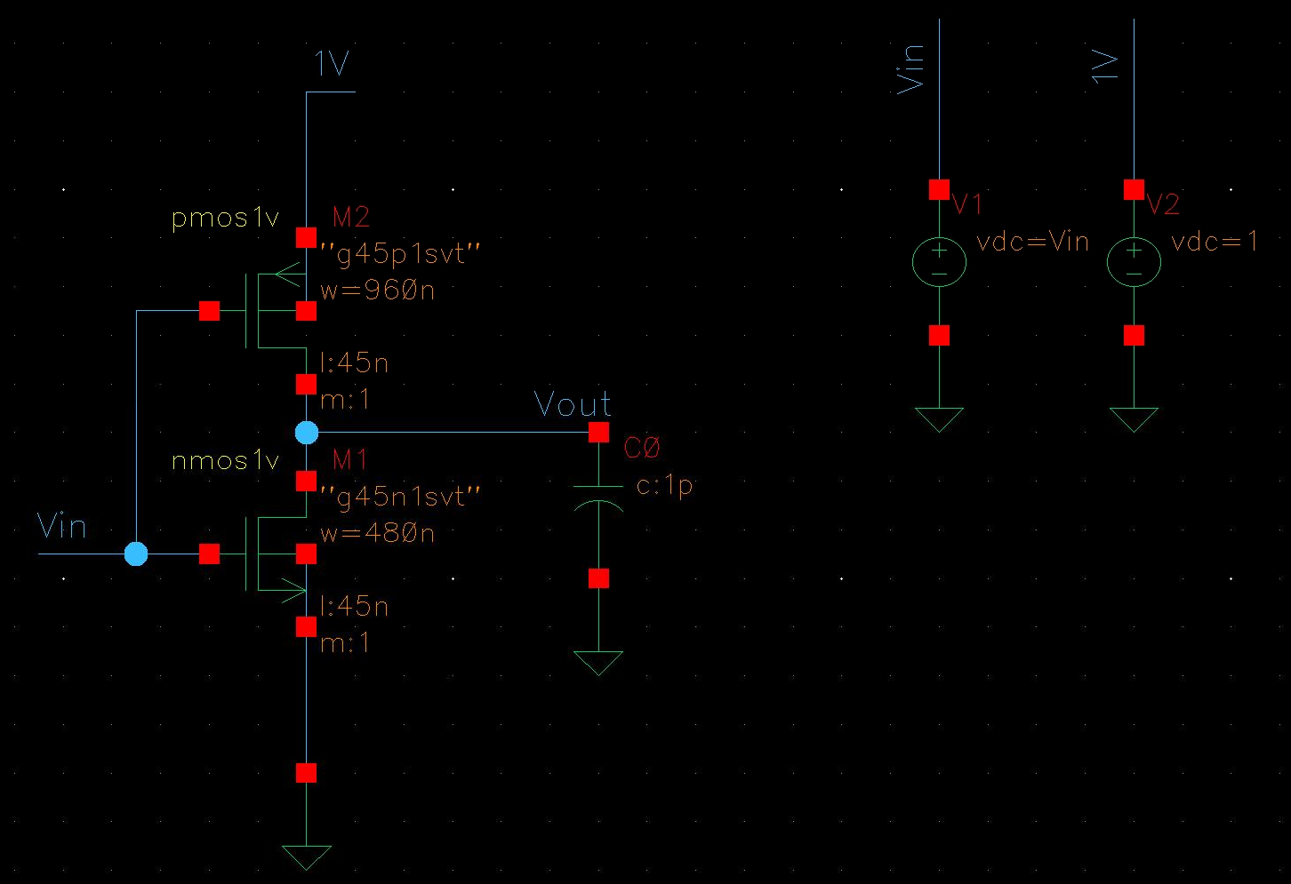

Couldn’t get past DC sweep of either inverter (step 1). I hate that I struggle with this class, I hate that I didn’t start on the assignment until the morning it was due, I hate that I didn’t find the proper tutorial until 30 minutes before the due time, and I hate that I never go to any of the office hours. It’s honestly a fucking miracle if I pass this semester.

I’m going to keep working on the assignment. If you care to check my work (assuming I ever get finished) then reach out and I can send it to you. Otherwise I’m keeping it to myself.